SPENDING DATA FOR THE MONTH OF SEPTEMBER
Insight to Observe:
1.Which of the items takes more from the income?
2. From which source do I receive more income?

1.Which of the items takes more from the income?
The bar chat below tells us that the bulk of the income is spent on your wife which is a responsibility to be fulfilled as the man of the house, however it should be judiciously spent over time.
Moreover, transfer, gift, grocery and foodco are items that you have control over. You can weigh these items into serious consideration by spending less on them.
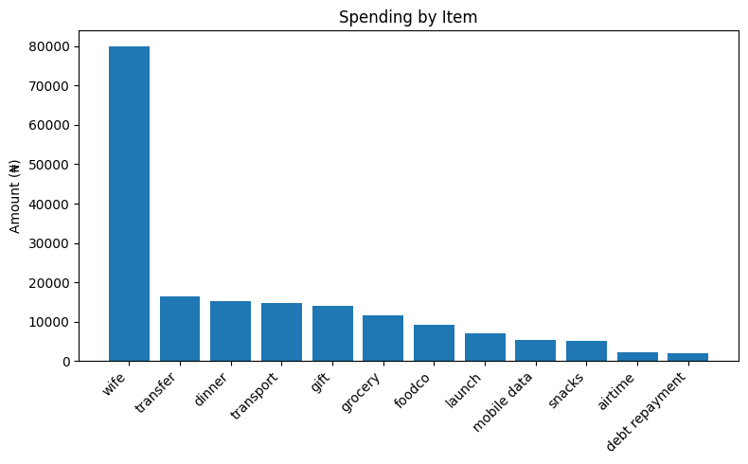
2. From which source do I receive more income?
The below chat tells us that the main income source is the salary and self transfer from his other financial institution meaning that; there is no other source of income than his salary and savings. It is however, important for him to find alternative means of generating income to care for expanded future expenditure.
